Thinking about a special person

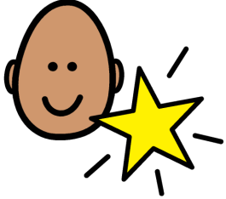 | A special person is someone you love or like being with.
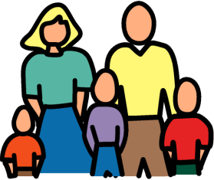  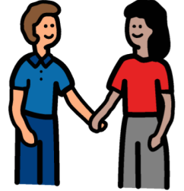  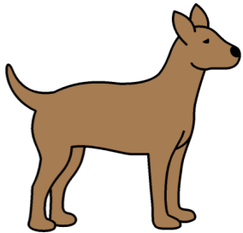 | This could be someone in your family  a friend  or an animal.
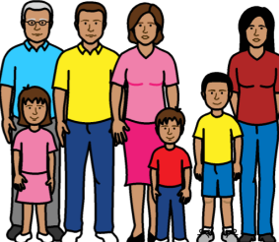 | Being with people  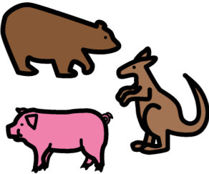  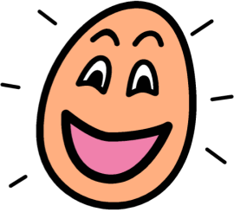  and animals we like helps us feel happy.
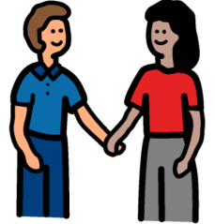  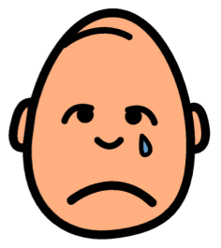 | It may be hard to be you’re your family  or friends at the moment.  This might make you feel sad.
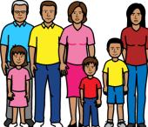  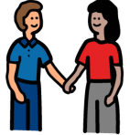  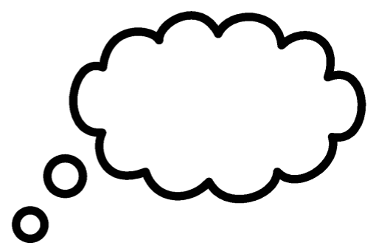 | Thinking about our friends and family can help us feel happy again.
Some ways to think about family and friend are:

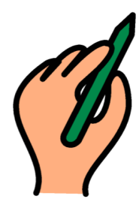  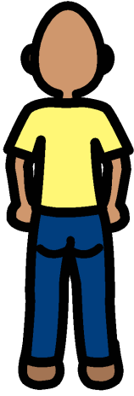 | Draw a picture of the person.
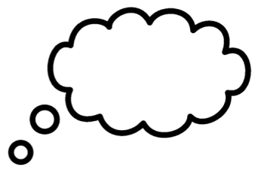 | Draw or write about happy memories.
 | Draw or write about how they make you feel.
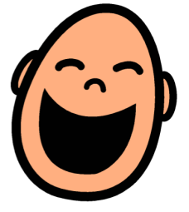 | Draw or write about what you like about them, for example, maybe they make you laugh.
Practice a ‘friend meditation’.

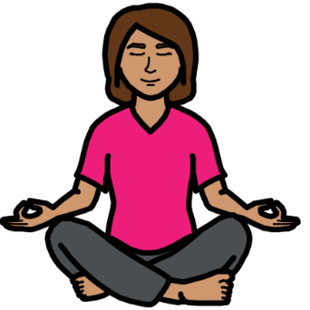  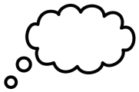 | Meditation is when you sit still in one place and think about how you are feeling.
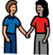      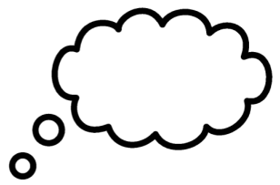 | During friend meditation you think about a special person, someone who makes you feel happy. This could be a friend or someone in your family.
  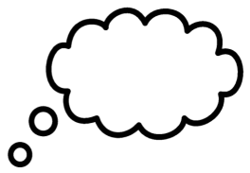  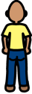  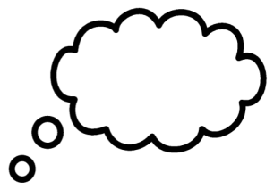  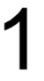 | Choose one person at a time and try to think about how you feel when you are with them.  You could use a photograph to help you think about them in your mind.
Thinking about a special person
Friend meditation.

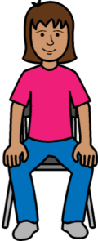  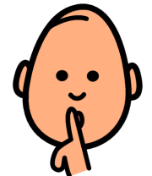 | Find a quiet place to sit.
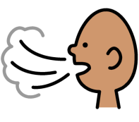  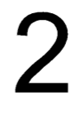 | Take 2 deep breaths.
 | Pick a special person to think about.
   | Think about that person. Try to picture them in your head or look at a photo of them.
  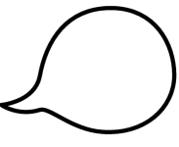 | What do they look like? What kinds of things do they say?
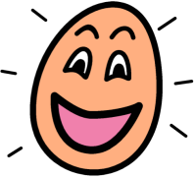 | What do they do to make you feel happy?  What do you like about them?  Their smile, kindness or maybe they are funny.  Anything else?
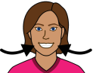  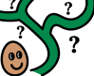     | See if you can remember a time when you were with that person and felt happy.  Where were you?  What were you doing?  Think about yourself smiling and feeling happy with that person.
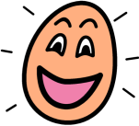  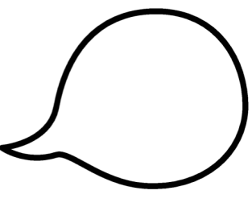 | You can say words like ‘happy’ in your head or out loud.
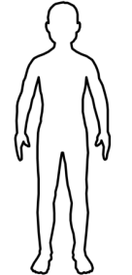  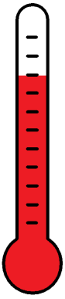 | Think about how your body feels when you think about your special person, for example it might feel warm.
 | Take 2 deep breaths.
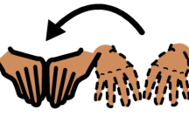  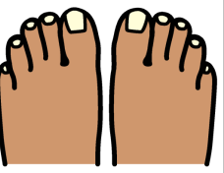 | Move your fingers and toes
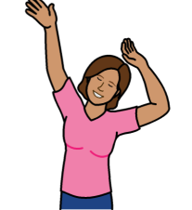  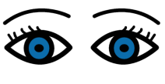 | Open your eyes and have a stretch.
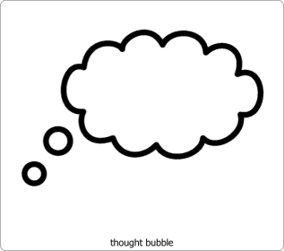   | You can think about your special person when you are feeling sad. This will make you feel happy.

